APTECH SITE CENTER
E.Project REPORT
─────────────────────────────
APPLIFY
Recruitment Management System
A Complete Web-Based HR & Hiring Solution=
Submitted By | Hira,Tehzeeb,Abdullah,Maaz
Instructor | Sir Usama
Institute | Aptech Site Center
Submission Date | 26 September 2026
Student ID

HTML | CSS | JAVA SCRIPT

Table of Contents-BUDGETBASICS
1. | Acknowledgements | 3
2. | Project Synopsis | 4
3. | Project Analysis | 6
4. | Project Design | 8
4.1 | Website Structure | 8
4.2 | Flowchart | 11
4.3 | Process Diagrams | 13
4.4 | User Interface Design | 14
5. | Screenshots | 17
6. | Source Code with Comments | 20
7. | User Guide (User Manual) | 24
8. | Developer's Guide | 28

1. Acknowledgements

All praise is due to Almighty Allah, Who blessed us with knowledge, strength, and patience to complete our Budget-Basics project successfully.

Our Instructor . Sir Usama
We are deeply grateful to Sir Usama for his valuable guidance, patience, and continuous support throughout the development of Budget-Basics. His technical guidance and constructive feedback helped us improve our understanding of web development and apply our skills to create a functional and user-friendly website.

Aptech Site Center
We extend our sincere gratitude to Aptech Site Center for providing us with a supportive learning environment, computer laboratory facilities, and the resources required for developing and testing our project.

Our Families
We would also like to thank our families for their continuous moral support, encouragement, and patience during the development and documentation of Budget-Basics. Their motivation helped us remain focused and complete our project successfully.
HIRA KHAN  Team Member & Frontend Developer | TEHZEEB FATIMA  Team Leader & Frontend Developer
ABDULLAH NAWAZ  Team Member & Frontend Developer | MAAZ  Team Member & Frontend Developer

2. budget-basic Synopsis

| 2.1 Project Title
Budget-Basics – Personal Budgeting & Financial Awareness Website | 2026

| 2.2 Project Overview
Budget-Basics is a modern and user-friendly single-page website designed to help users understand and manage their basic budgeting and financial planning needs. The main purpose of the website is to provide simple and useful information about budgeting, expenses, savings, and responsible money management in an easy-to-understand format.
The website presents different budgeting-related sections in a clean and attractive interface. Users can explore budgeting information, understand the importance of saving, review their spending habits, and use interactive features provided through JavaScript.
Budget-Basics focuses on simplicity, accessibility, and an engaging user experience. The website is designed as a single-page web application, where users can navigate between different sections without opening multiple separate pages.
The project primarily uses HTML5, CSS3, JavaScript, Bootstrap 5, and Font Awesome. HTML5 is used to create the website structure, CSS3 is used for styling and visual design, JavaScript provides interactive functionality and calculations, while Bootstrap 5 helps make the website responsive on different screen sizes.
The main goal of Budget-Basics is to provide users with a simple digital platform that promotes better understanding of personal budgeting and encourages organized financial planning.

| 2.3 Objectives
The main objectives of the Budget-Basics project are:
- To provide users with a simple and user-friendly platform for understanding basic budgeting concepts.
- To help users organize their income, expenses, savings, and daily spending habits.
- To provide basic budgeting and financial planning information in an easy-to-understand format.
- To use JavaScript to provide interactive features and basic calculations related to budgeting.
- To create a clean, attractive, and responsive single-page website that works effectively on different screen sizes.
- To use Bootstrap 5 for responsive layouts and user interface components.
- To encourage users to develop better saving and spending habits through useful budgeting information.
- To provide an easy-to-navigate interface where users can access different sections of the website from a single page.
- To develop the website using modern web technologies including HTML5, CSS3, JavaScript, Bootstrap 5, and Font Awesome.
- To create a visually appealing website that provides a simple and engaging user experience.

| 2.4 Scope
The scope of the Budget-Basics project includes the following features:
- Budgeting Information – Provides users with basic information and guidance about budgeting and financial planning.
- Income & Expense Planning – Helps users understand how to organize their income and manage their daily expenses.
- Savings Guidance – Provides useful information and tips to encourage better saving habits.
- Budget Calculator – Uses JavaScript to perform basic budgeting calculations and help users understand their spending and saving amounts.
- Interactive Sections – Includes interactive elements that allow users to engage with different sections of the website.
- Responsive Design – The website is designed to work properly on desktops, laptops, tablets, and mobile devices.
- Single-Page Navigation – All major information and features are presented on a single webpage with easy navigation between sections.
- User-Friendly Interface – Provides a simple, attractive, and easy-to-use interface for users.
- Visual Design – Uses CSS3, Bootstrap 5, and Font Awesome to create an organized and visually appealing website.
- Financial Awareness – The website aims to increase users' awareness about responsible spending, saving, and basic personal financial management.

| 2.5 Technology Stack
Technology | Details
HTML5 | Used to create the basic structure and content of the Budget-Basics website.
CSS3 | Used for styling, layouts, colors, spacing, animations, and overall visual appearance.
JAVASCRIPT | Used for interactive features, budgeting calculations, buttons, and dynamic website behavior
BOOTSTRAP5 | Used for responsive design, grid system, components, and mobile-friendly layouts
Frontend AWESOME | Used to add icons throughout the website and improve the user interface.
Development Tool | Visual Studio Code is used for writing, editing, and managing the website code.
Website Type | Single-page website focused on budgeting and financial awareness.
Authentication | Cookie-Based . Multi-Scheme (UserAuth + AdminAuth)

| 3.1 Problem Statement
Many people, especially students and young adults, find it difficult to manage their daily income, expenses, and savings. Traditional budgeting methods often rely on notebooks, manual calculations, or simple notes, which can be time-consuming and difficult to organize.
Users may not have a simple platform where they can learn basic budgeting concepts, understand their spending habits, and perform basic budget calculations in one place.
Budget-Basics addresses these issues by providing a simple, user-friendly, and interactive single-page website that presents budgeting information and basic financial planning tools in an organized digital format.

| 3.2 Existing System Problems
- Manual Budgeting – Users often calculate their income and expenses manually, which can result in calculation mistakes.
- Lack of Budgeting Awareness – Many users do not have sufficient knowledge about creating and maintaining a personal budget.
- Difficulty Tracking Expenses – Without proper planning, users may find it difficult to understand where their money is being spent.
- Poor Saving Habits – Lack of organized financial planning can make it difficult for users to set aside money for savings.
- Scattered Information – Budgeting tips and financial information are often available from different sources rather than in one simple platform.
- No Interactive Calculation – Traditional methods generally do not provide an easy and interactive way to calculate basic income, expenses, and savings.
- Limited Accessibility – Paper-based budgeting methods cannot provide the convenience of accessing information and calculations through a responsive website.
Budget-Basics provides a simple digital solution by bringing budgeting information, financial awareness,

| 3.3 Proposed System . BUDGET-BASIC Solutions
The proposed Budget-Basics system is a single-page website designed to provide users with simple and accessible budgeting and financial planning information. The system focuses on helping users understand their income, expenses, savings, and basic money management.
The proposed system includes the following features:
- Budgeting Information – Provides clear and simple information about budgeting and personal financial planning.
- Income & Expense Management – Helps users understand how to organize their income and control their daily expenses.
- Interactive Budget Calculator – Uses JavaScript to perform basic calculations related to income, expenses, and savings.
- Savings Guidance – Provides useful tips and information to encourage users to develop better saving habits.
- Interactive User Interface – Includes buttons, sections, and JavaScript-based interactions to make the website more engaging.
- Responsive Website Design – Uses Bootstrap 5 and CSS3 to ensure the website can be viewed properly on different devices and screen sizes.
- Single-Page Navigation – Provides access to the main sections through a single webpage, making navigation simple and convenient.
- Financial Awareness – Helps users develop a better understanding of responsible spending, saving, and basic financial planning.
Overall, Budget-Basics provides a simple digital platform that combines budgeting information, financial awareness, and interactive calculations in one user-friendly website.

| 3.4 Feasibility Analysis

3.4.1 Technical Feasibility
Budget-Basics is technically feasible because it is developed using common and widely supported web technologies such as HTML5, CSS3, JavaScript, and Bootstrap 5. These technologies are suitable for developing responsive and interactive websites and are supported by modern web browsers.
The development team has basic skills in frontend web development and can work with HTML, CSS, JavaScript, and Bootstrap. JavaScript is used to provide interactive features and basic budgeting calculations, while Bootstrap helps create a responsive layout for different screen sizes.
The project does not require any specialized hardware, server, or database system. A standard computer with a modern web browser and a development environment such as Visual Studio Code is sufficient for developing, testing, and running the Budget-Basics website.
Therefore, the technical requirements of the project are simple, accessible, and suitable for the development of a single-page website.
.

3.4.2 Operational Feasibility
Budget-Basics is operationally feasible because it provides a simple, clear, and user-friendly interface. Users can easily navigate through the single-page website and access budgeting information, financial tips, and interactive features without requiring specialized technical knowledge.
The website is designed according to basic UI/UX principles, with clear sections, readable content, simple navigation, and responsive design. JavaScript-based interactive features are designed to be easy to understand and use.
The system requires minimal user training because users can access the different sections directly through the website. The User Guide included in this documentation provides additional information about using the website and its features.
Overall, Budget-Basics is easy to operate and suitable for users who want a simple digital platform for learning about budgeting and basic financial planning.

3.4.3 Economic Feasibility
Budget-Basics is economically feasible because the project is developed using freely available and commonly used web development technologies such as HTML5, CSS3, JavaScript, and Bootstrap 5. These technologies do not require expensive software licenses for the development of a basic website.
The project can be developed and tested using a standard computer and Visual Studio Code, which helps keep development costs low. Since Budget-Basics is a single-page website and does not require a dedicated database server or specialized hardware, there are no significant infrastructure costs.
The use of free development resources and web technologies makes Budget-Basics a low-cost project that can be developed within a basic student project budget.

| 3.5 Functional Requirements
Req. ID | Module | Requirement
FR-01 | Website Navigation | Users can navigate between different sections of the single-page website using the navigation menu.
FR-02 | Budgeting Information | Users can view basic information and guidance about budgeting and financial planning.
FR-03 | Income & Expense | Users can enter or review basic income and expense information for budgeting purposes.

| 3.6 Non-Functional Requirements
• Performance – The website should load quickly and display its content smoothly under normal internet conditions.
• Usability – The website should have a simple, clear, and user-friendly interface so that users can easily understand and use its features.
• Responsive Design – The website should work properly on different screen sizes, including desktops, laptops, tablets, and mobile devices.
• Accessibility – Important content, navigation options, buttons, and interactive elements should be clearly visible and easy to use.
• Reliability – JavaScript calculations and interactive features should provide accurate and consistent results under normal usage conditions.
• Maintainability – The HTML, CSS, and JavaScript code should be organized so that future changes and updates can be made easily.
• Compatibility – The website should function correctly on commonly used modern web browsers such as Google Chrome, Microsoft Edge, and Mozilla Firefox.
• Performance Efficiency – The website should avoid unnecessary resources and maintain smooth interaction despite being a single-page website.
• Visual Consistency – Fonts, colors, buttons, cards, icons, and other interface elements should maintain a consistent design throughout the website.

ata Flow Diagrams (DFDs)
Data Flow Diagrams show how information moves through the Budget-Basics website between the user and the different features of the system.
Since Budget-Basics is a single-page frontend website, the main data flow focuses on user input, JavaScript-based calculations, and the display of results.
Level 0 – Context Diagram
User → Budget-Basics Website → Results / Information
- User opens the Budget-Basics website.
- User explores budgeting and financial information.
- User enters income and expense values where required.
- The website processes the entered information using JavaScript.
- Budget calculations and results are displayed to the user.
Level 1 – Main Data Flow
User
↓
Budget-Basics Single-Page Website
↓
Budgeting Information / Income & Expense Input
↓
JavaScript Processing & Calculation
↓
Budget / Savings Result
↓
User
The DFD demonstrates that Budget-Basics receives information from the user, processes basic calculations through JavaScript, and displays the relevant results and financial guidance on the webpage.
Note: Budget-Basics does not use a server-side database or admin panel, so no database data store is included in the DFD.
.

4.1.1 Context Diagram . Level 0 DFD
The Level 0 Context Diagram represents Budget-Basics as a single system interacting with the user. It shows the basic flow of information between the user and the website.
LEVEL 0 . CONTEXT DIAGRAM (Budgetbasic-system)
+------------------+
| user |
+------------------+
| |
| Income / Expense | Information | User Interaction v | | Vacancy Info / Status Updates
| |
v |
+-------------------------+
| |
| |budget-basic
| |
+-------------------------+
| ^
Budget Calculation | Results | Financial Tips | Budgeting Information v |
+------------------+
| user |
+------------------+
4.1.2 Level 1 DFD – User Module
The Level 1 DFD shows the main processes performed by the user while interacting with the Budget-Basics single-page website.
LEVEL 1 DFD – USER PROCESSES
+------------------+
| USER |
+------------------+
|
+-----------------+------------------+
| | |
v v v
[P1: Explore [P2: Enter [P3: Use Budget
Budgeting Info] Income/Expenses] Calculator]
| | |
v +--------+---------+
|
v
[P4: JavaScript
Processing]
|
v
[P5: Display Budget
/ Savings Result]
|
v
+------------------------+
| USER |
+------------------------+

[P6: View Financial Tips]
|
v
[Budgeting Information]
|
v
USER
Main Processes
- P1: Explore Budgeting Information – User views information about budgeting and financial planning.
- P2: Enter Income/Expenses – User enters basic income and expense values where required.
- P3: Use Budget Calculator – User uses the interactive budgeting calculator.
- P4: JavaScript Processing – JavaScript processes the entered values and performs the required calculations.
- P5: Display Budget/Savings Result – The calculated result is displayed to the user.
- P6: View Financial Tips – User views useful tips related to saving, spending, and budgeting.
Note: No database or separate data-store is shown because Budget-Basics is a frontend single-page website and does not use a server-side database.

4.1.3 Level 1 DFD – Website Interaction Module
The Level 1 DFD describes the main interactive processes available in the Budget-Basics website. It focuses on user interaction, JavaScript calculations, and the display of results.
LEVEL 1 DFD – WEBSITE INTERACTION PROCESSES
+------------------+
| USER |
+------------------+
|
v
[P1: Open Website]
|
v
[P2: Explore Sections]
|
+-------------+-------------+
| |
v v
[P3: View Budgeting [P4: Enter Income
Information] & Expenses]
| |
| v
| [P5: JavaScript
| Calculation]
| |
| v
| [P6: Display Budget
| / Savings Result]
| |
+-------------+-------------+
|
v
+------------------+
| USER |
+------------------+
Main Processes
- P1: Open Website – User opens the BudgetBasics single-page website.
- P2: Explore Sections – User navigates through the available sections of the webpage.
- P3: View Budgeting Information – User reads budgeting, saving, and financial planning information.
- P4: Enter Income & Expenses – User enters the required financial values.
- P5: JavaScript Calculation – JavaScript processes the entered values and performs the required calculations.
- P6: Display Budget/Savings Result – The website displays the calculated result to the user.
Note: BudgetBasics does not contain an Admin Module, authentication system, or server-side database. Therefore, an Admin DFD and database data stores are not required for this project.

|
4.2 Flowcharts
4.2.1 Budget Calculator Flowchart
FLOWCHART – BUDGET CALCULATION
( START )
|
v
[Open BudgetBasics]
|
v
[Enter Total Income]
|
v
[Enter Total Expenses]
|
v
< Are Values Valid? >
/ \
NO YES
| |
v v
[Show Error] [Calculate Remaining
| Amount / Savings]
| |
+-------> v
[Display Result]
|
v
[View Budget Tips]
|
v
( END )
Flow Description
- Start – The user opens the BudgetBasics website.
- Enter Income – The user enters their total income.
- Enter Expenses – The user enters their total expenses.
- Validation – The system checks whether the entered values are valid.
- Calculation – JavaScript calculates the remaining amount after expenses.
- Display Result – The calculated budget or savings amount is displayed to the user.
- Budget Tips – The user can view relevant budgeting and saving tips.
- End – The budgeting process is completed.

4.2.2 Budget Calculation Flowchart
FLOWCHART – BUDGET CALCULATION PROCESS
( START )
|
↓
[Open BudgetBasics Website]
|
↓
[Enter Total Income]
|
↓
[Enter Total Expenses]
|
↓
< Values Valid? >
/ \
NO YES
| |
↓ ↓
[Show Validation [JavaScript
Error] Processing]
| |
| ↓
| [Calculate Remaining
| Budget/Savings]
| |
| ↓
| [Display Calculation
| Result]
| |
| ↓
| [View Budgeting &
| Savings Tips]
| |
└──────────────┤
↓
( END )
Flowchart Description
The Budget Calculation Flowchart represents the basic process through which a user can calculate their remaining budget using the BudgetBasics website.
- Start: The process begins when the user opens the BudgetBasics website.
- Open BudgetBasics Website: The user accesses the single-page website and navigates to the budgeting or calculator section.
- Enter Total Income: The user enters their available income or total monthly income.
- Enter Total Expenses: The user enters the total amount of their expenses.
- Validate Values: JavaScript checks whether the entered values are valid and suitable for calculation.
- Validation Error: If the entered values are missing, invalid, or incorrect, the website displays a validation message and allows the user to correct the information.
4.2.3 Financial Planning Tips Flowchart
FLOWCHART – FINANCIAL PLANNING PROCESS
( START )
|
↓
[Open BudgetBasics]
|
↓
[Explore Website Sections]
|
↓
[View Budgeting Information]
|
↓
[Enter Income & Expenses]
|
↓
< Need Calculation? >
/ \
NO YES
| |
↓ ↓
[Continue Exploring] [Calculate Budget]
| |
| ↓
| [Display Remaining
| Budget/Savings]
| |
└────────┬───────┘
↓
[View Financial Tips]
|
↓
[Review Saving Tips]
|
↓
( END )
Flowchart Description
The Financial Planning Flowchart describes how a user can interact with the main budgeting and financial awareness features of the BudgetBasics website.
- Start: The process begins when the user opens the BudgetBasics website.
- Explore Website Sections: The user navigates through the different sections available on the single-page website.
- View Budgeting Information: The user reads information related to budgeting, income, expenses, savings, and financial planning.
- Enter Income & Expenses: If the user wants to calculate their budget, they enter their income and expense amounts.
- Calculation Decision: The user can either continue exploring the website or use the budgeting calculation feature.
- Calculate Budget: JavaScript processes the entered values and performs the required budget calculation.
- Display Result: The website displays the remaining budget or potential savings based on the entered information.
- View Financial Tips: The user can then review financial and budgeting tips provided by the website.
- Review Saving Tips: The user can use these tips to improve their understanding of saving and expense management.
- End: The process ends after the user has reviewed the calculation and relevant financial information.

|
4.4 Website Data Handling & Structure
BudgetBasics is a single-page frontend website developed for budgeting and financial awareness. The website does not use a backend database or server-side data storage. Instead, the interactive budgeting features are handled on the client side using JavaScript.
The main data handled by the website is entered by the user for budgeting calculations, such as income and expenses. JavaScript processes these values and displays the calculated results directly on the webpage.
4.4.1 Data Handling Overview
The main data flow of BudgetBasics can be represented as follows:
- User Input → Budget Calculator
The user enters income and expense values into the budgeting section.
- Budget Calculator → JavaScript Processing
JavaScript receives the entered values and performs the required calculations.
- JavaScript Processing → Calculation Result
The calculated remaining budget or potential savings is displayed to the user.
- User → Financial Information
Users can also explore budgeting, saving, and financial awareness information available on the website.
4.4.2 Website Data Structure
Data/Input | Purpose | Processing
Income | Represents the user's available income | Processed by JavaScript
Expenses | Represents the user's spending amount | Processed by JavaScript
Remaining Budget | Shows the amount left after expenses | Calculated using JavaScript
Savings Amount | Helps the user understand possible savings | Calculated/displayed by JavaScript
Financial Tips | Provides budgeting and saving guidance | Displayed as website content
4.4.3 Database Requirement
BudgetBasics does not require a database because it is designed as a frontend-only single-page website. There is no user registration, login system, admin panel, applicant management, interview scheduling, or permanent record storage.
The website mainly uses HTML5, CSS3, JavaScript, Bootstrap 5, and Font Awesome. JavaScript is responsible for interactive features and basic budgeting calculations, while HTML and CSS are used to structure and design the interface.
Therefore, traditional database entities and relationships such as Users, Applicants, Vacancies, and InterviewSlots are not applicable to the BudgetBasics project.

5. Screenshots
The following screenshots represent the main sections and interactive features of the BudgetBasics – Personal Budgeting & Financial Awareness Website. Since BudgetBasics is a single-page frontend website, the screenshots focus on the different sections available within the same webpage.
Each screenshot should be captured from the running website and inserted under the relevant heading.

| 5.1 Homepage & Public Pages
5.1 Homepage & Main Sections
The homepage of BudgetBasics provides an overview of the website and introduces users to budgeting and financial awareness. It contains the main navigation, welcome section, visual elements, and important budgeting content.
Screenshot 5.1: BudgetBasics Homepage
Insert screenshot of the complete homepage/main hero section here.

The homepage of BudgetBasics provides an overview of the website and introduces users to budgeting and financial awareness. It contains the main navigation, welcome section, visual elements, and important budgeting content.
Screenshot 5.1: BudgetBasics Homepage
Insert screenshot of the complete homepage/main hero section here.

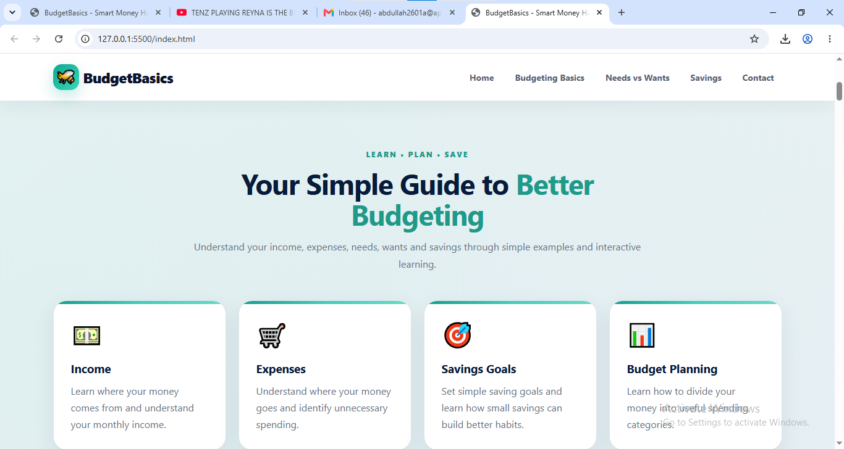

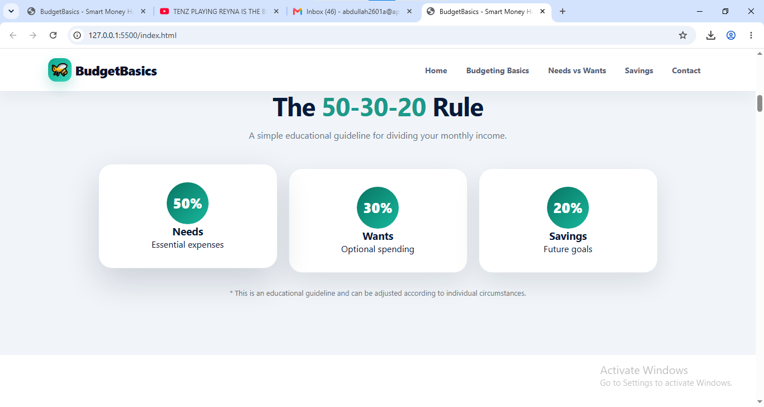

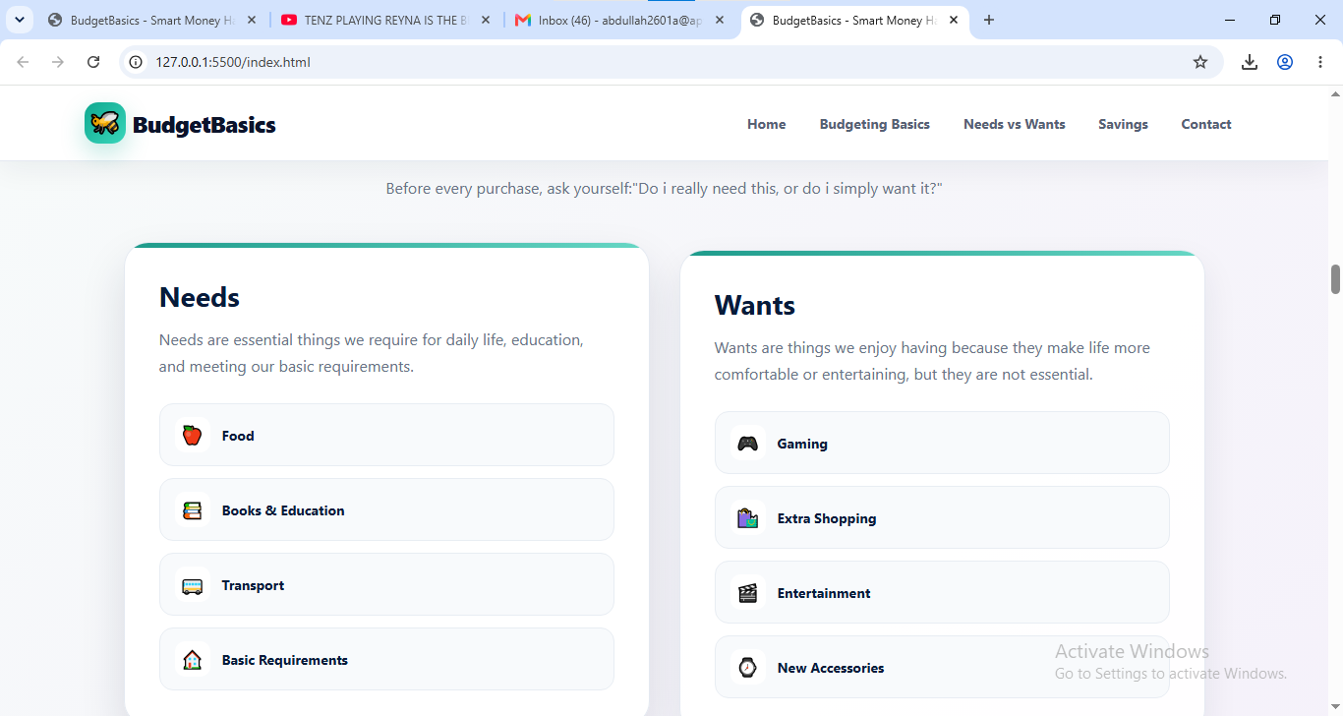

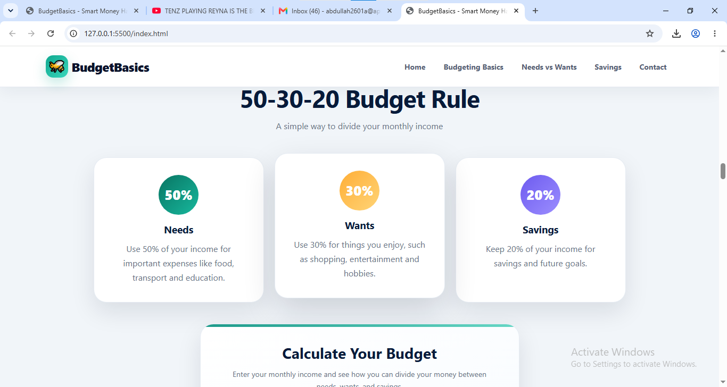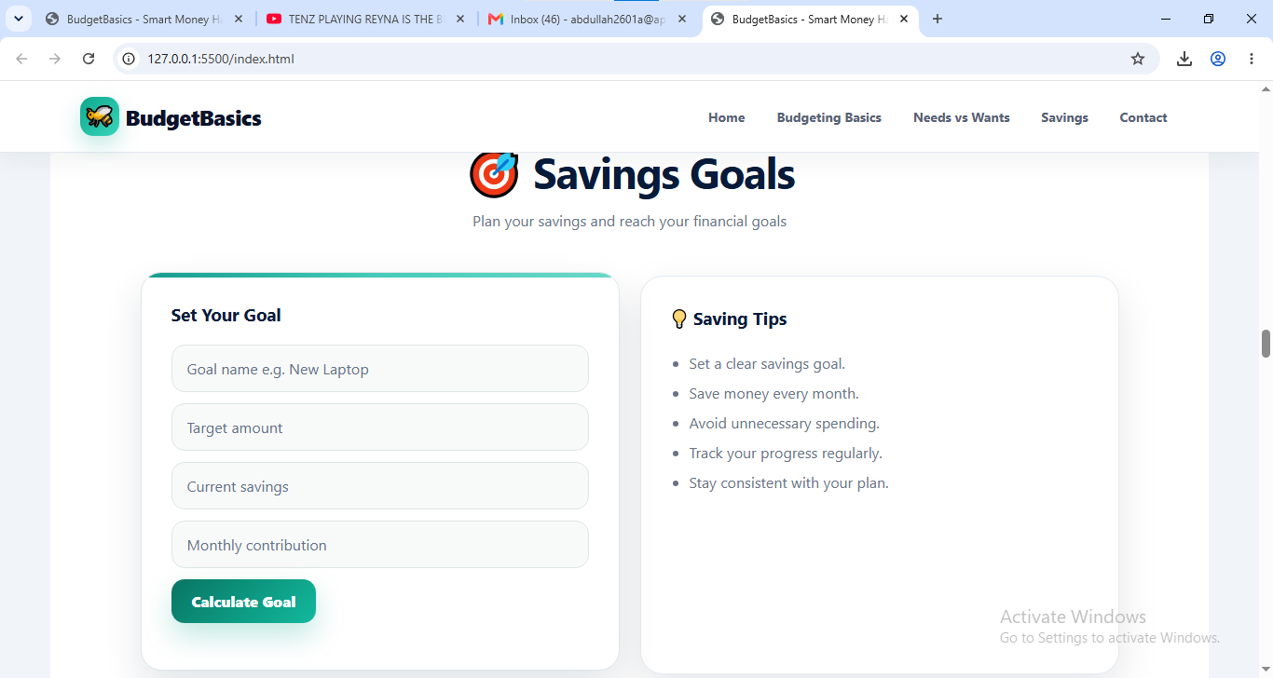

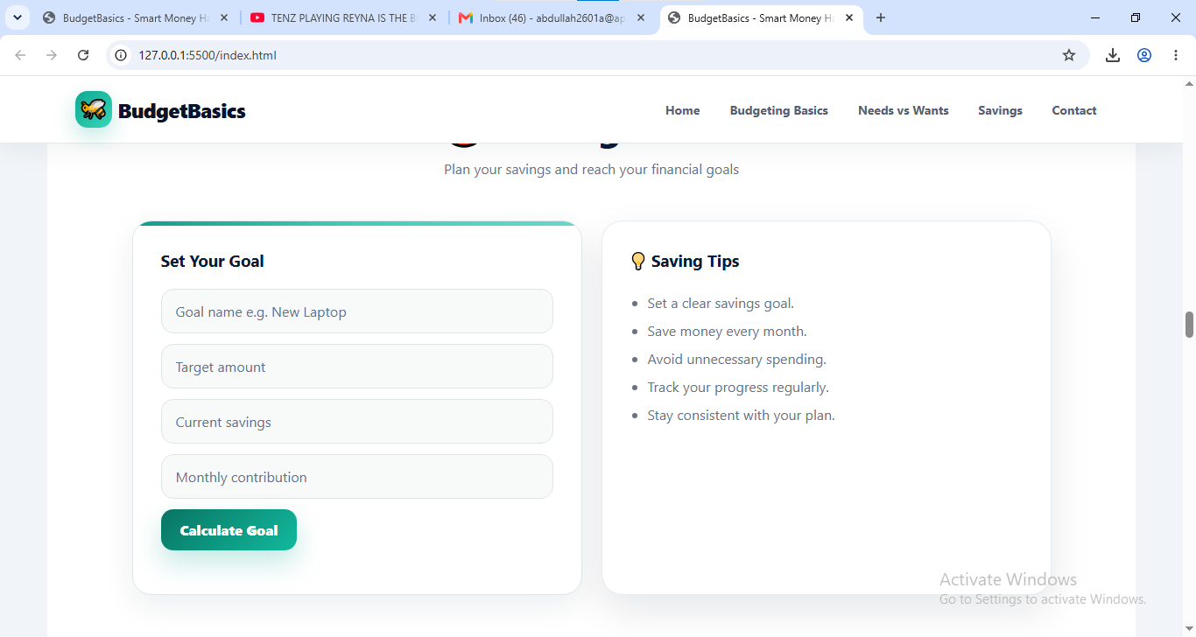

| 5.4 Admin Panel . HR Module
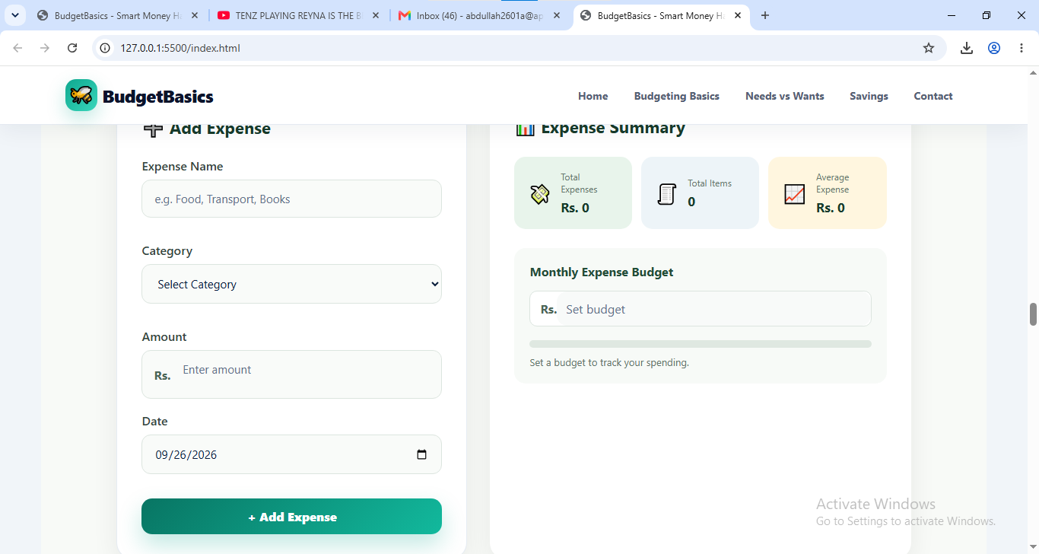

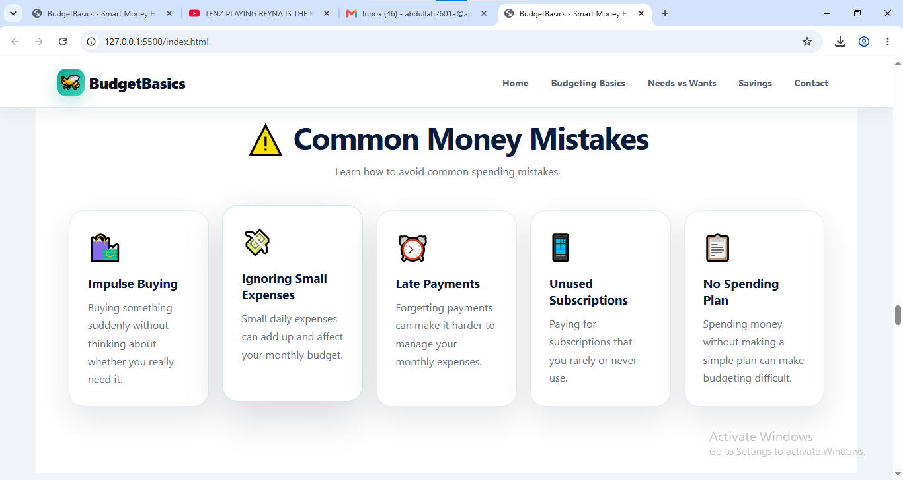

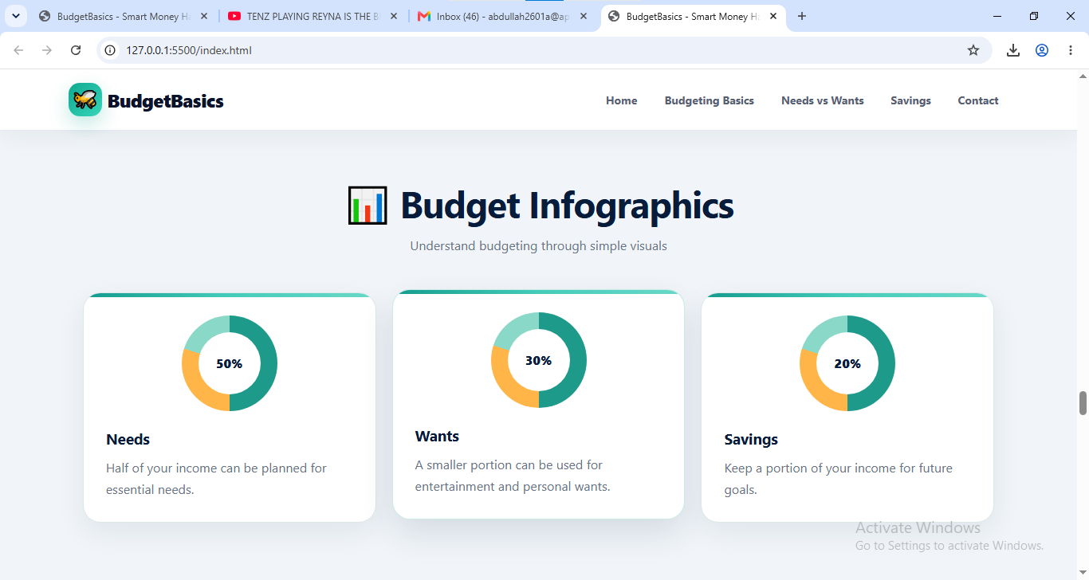

6. Source Code with Comments
The source code placeholders below indicate which file to paste in each section. Paste the actual source code from your Visual Studio project into each corresponding box below.

| 6.1 html
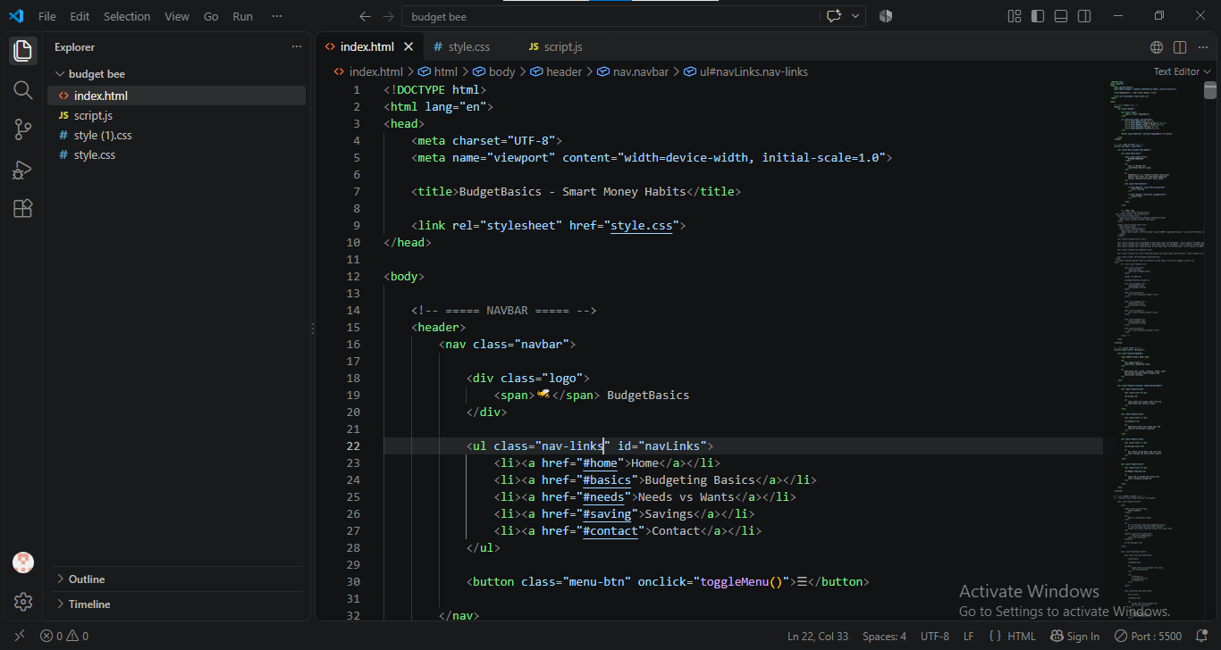

Home section
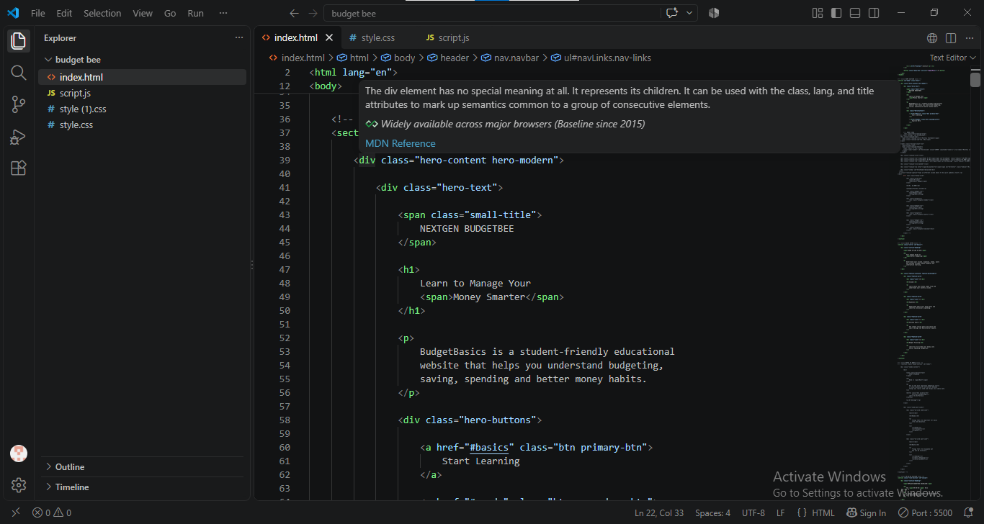

Quick intro
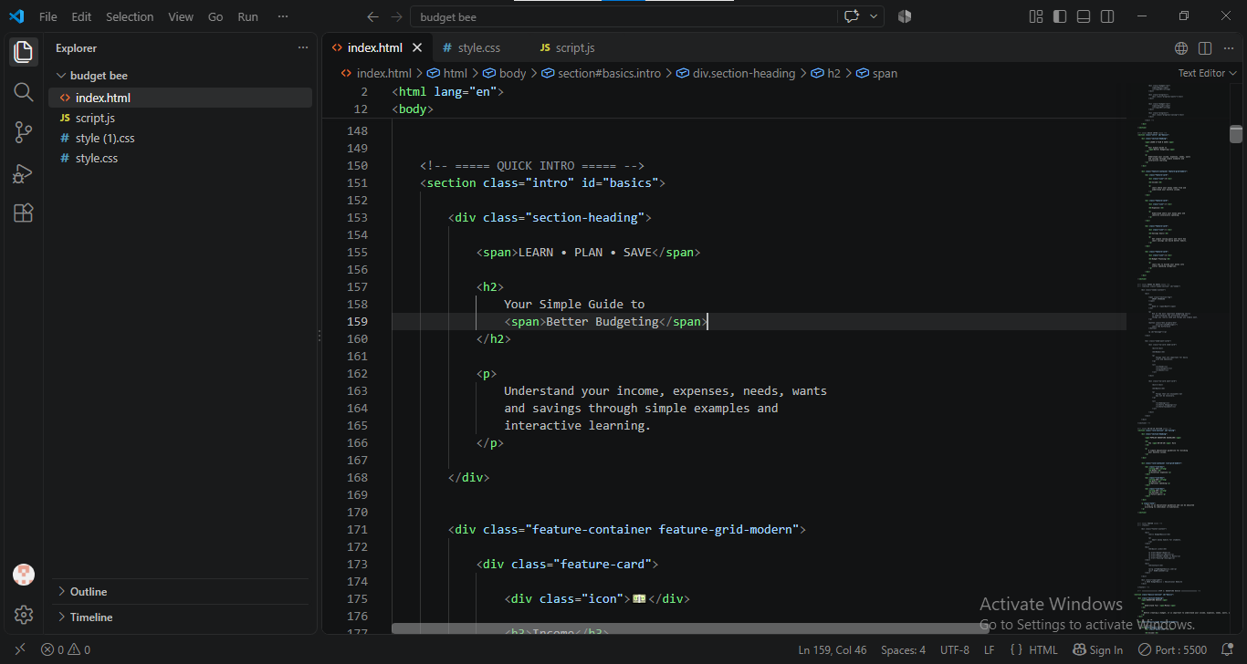

css
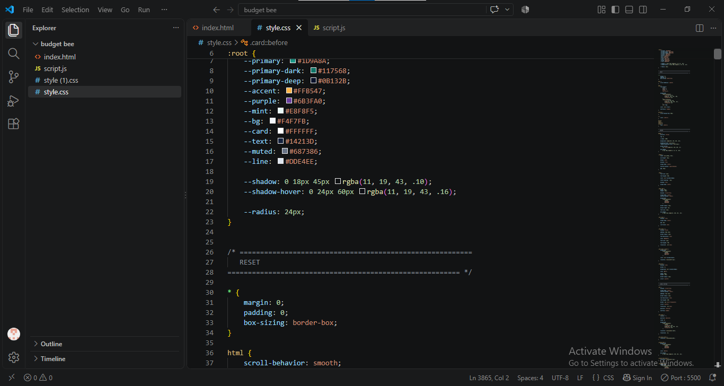

| 6.2 java script
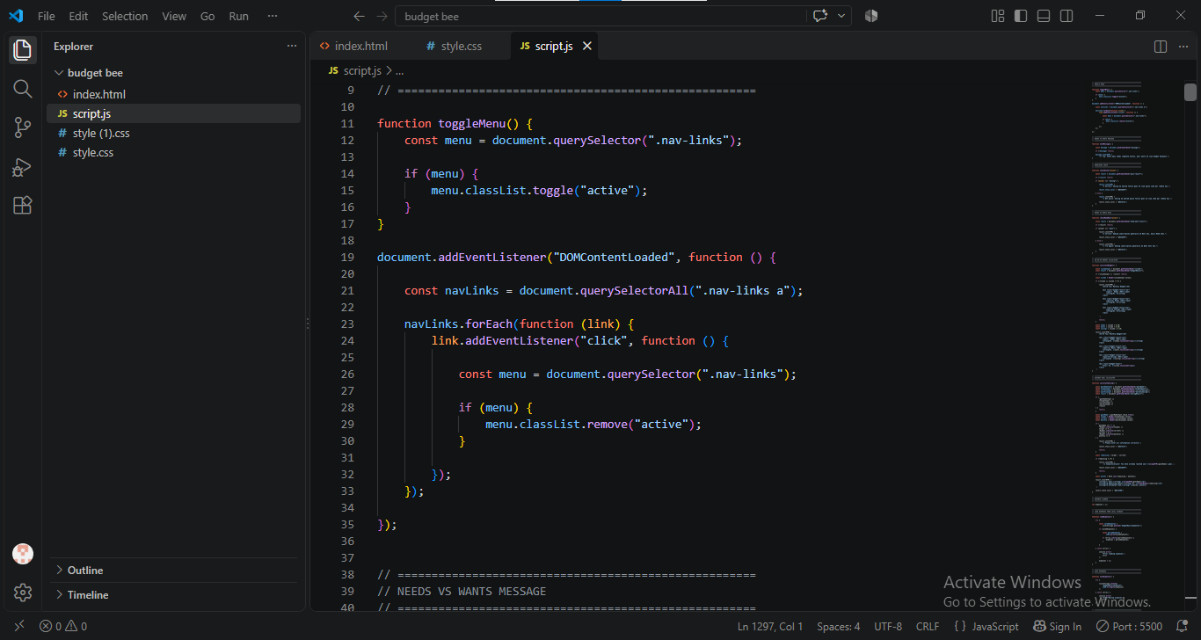

| 6.3
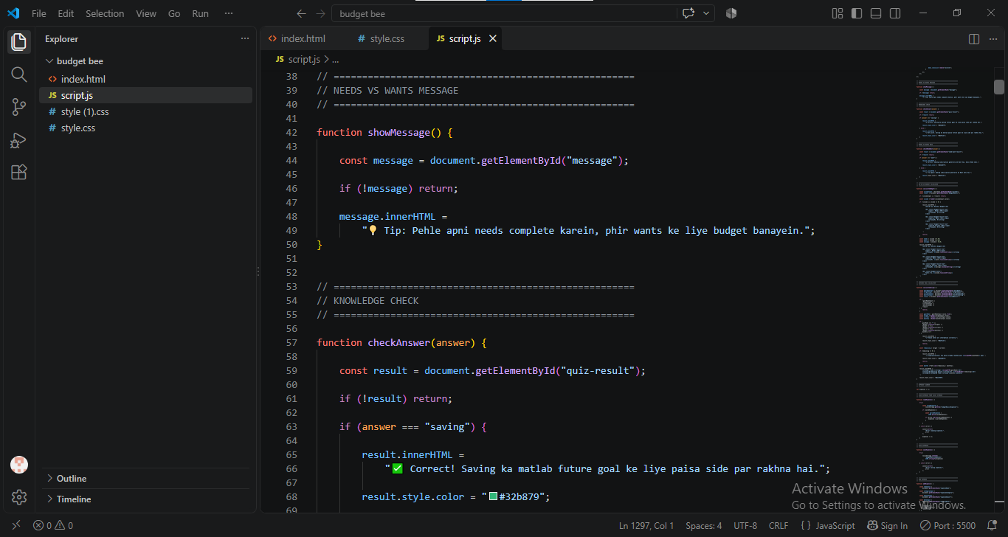

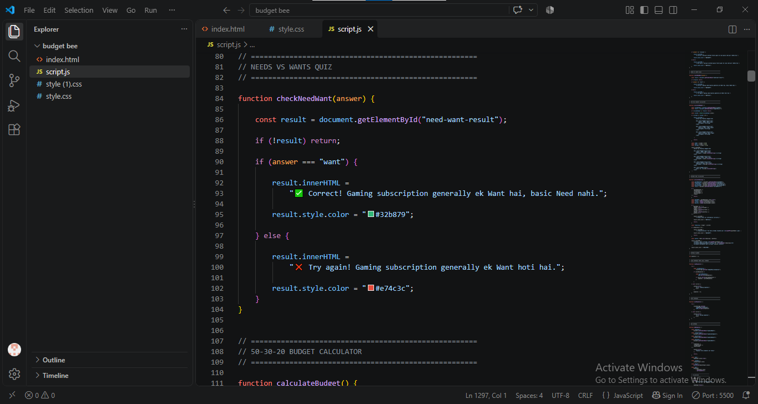

| 6.4
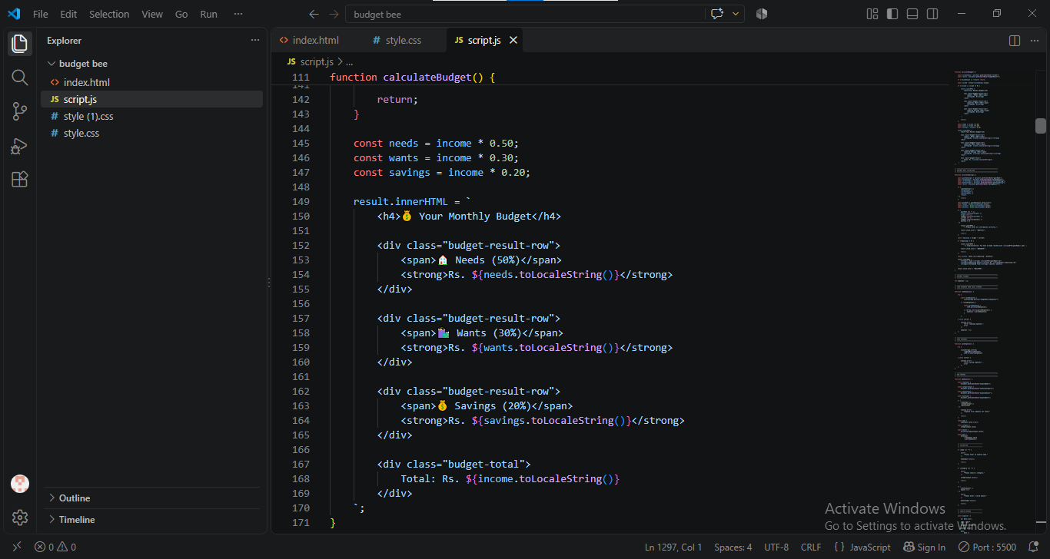

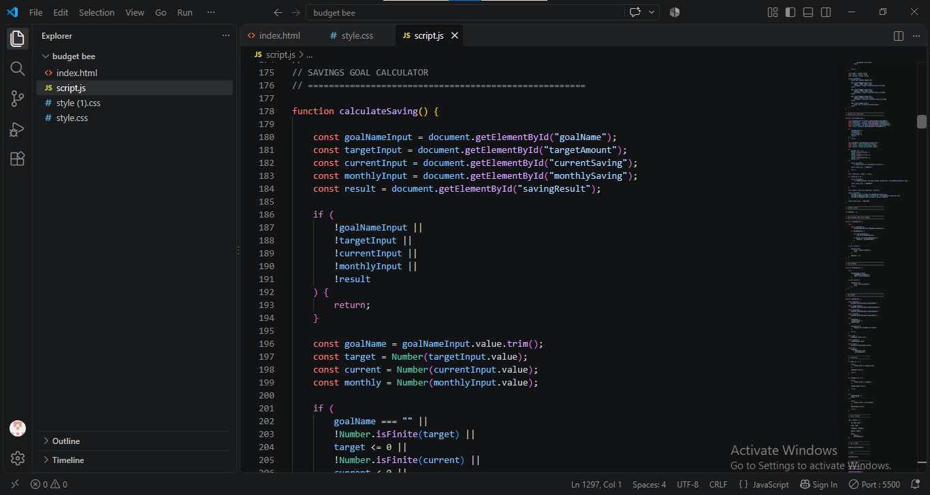

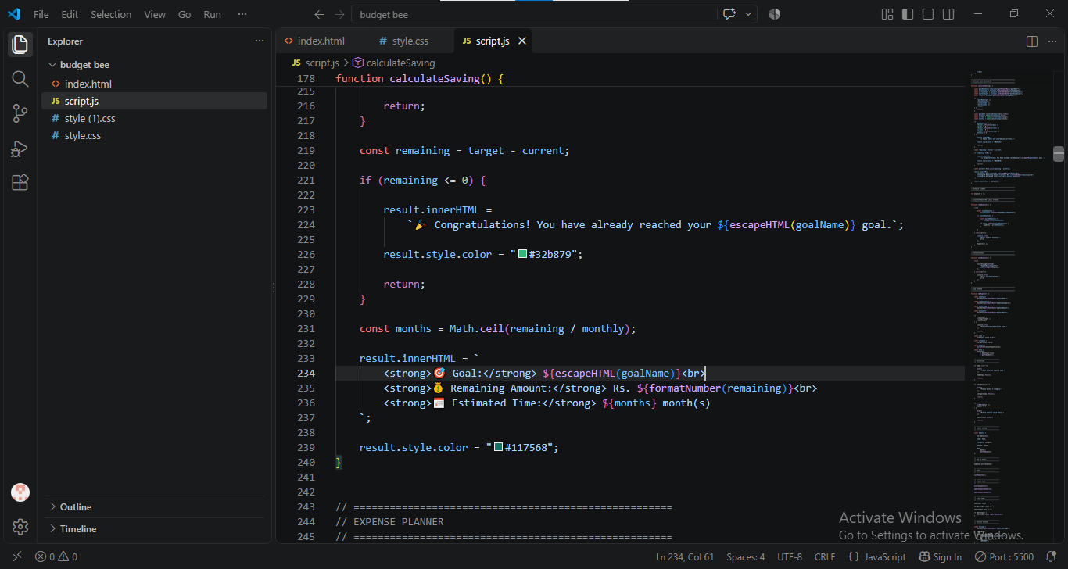

| 6.5
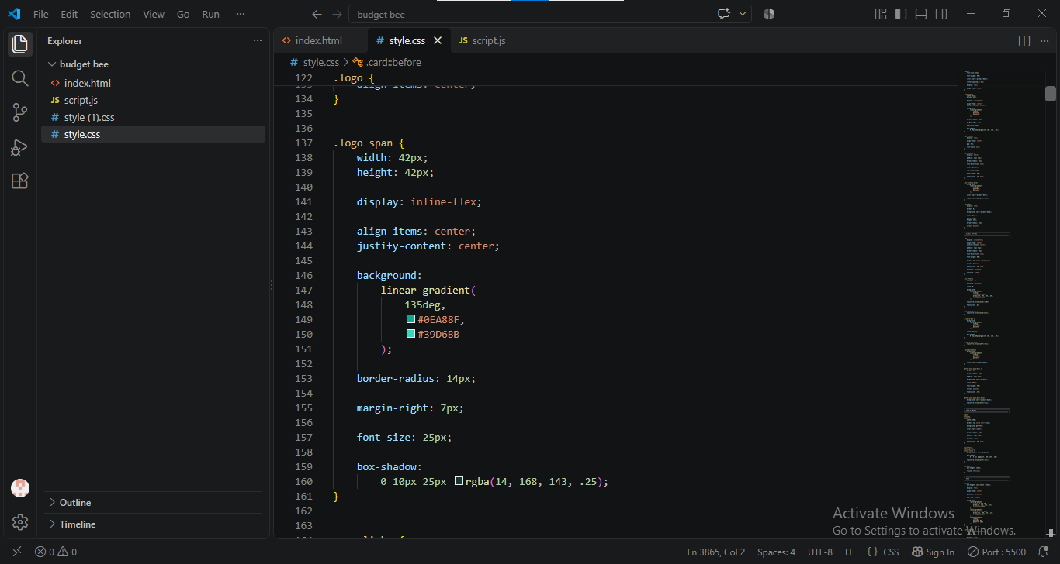

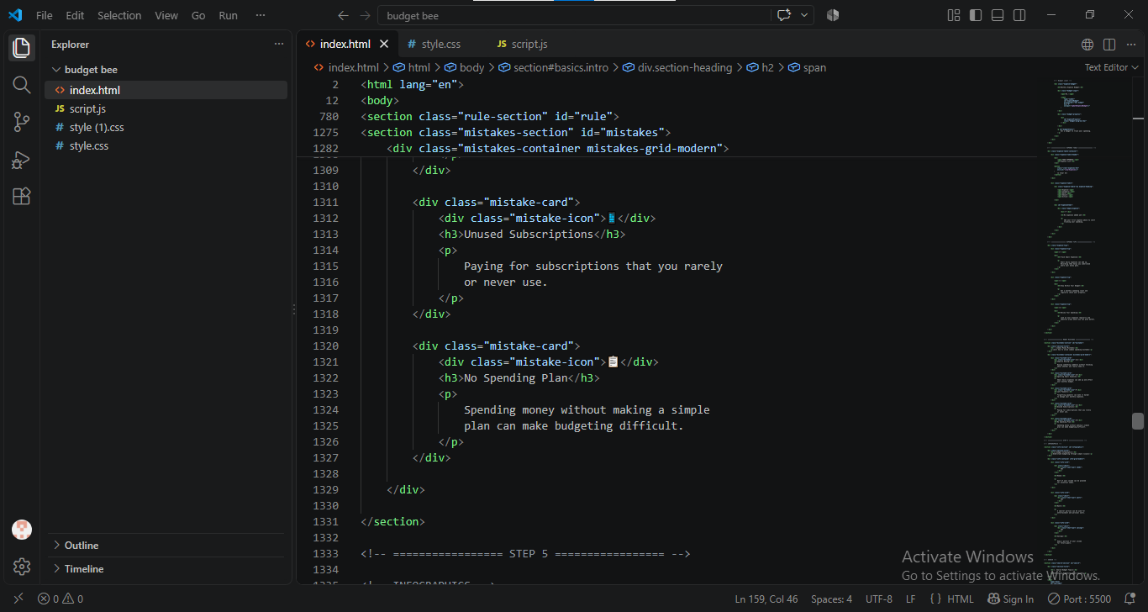

7. User Guide (User Manual)
This User Guide is prepared for users of the BudgetBasics – Personal Budgeting & Financial Awareness Website. It provides simple step-by-step instructions for accessing the website, exploring its different sections, using the budget calculator, and understanding the displayed financial information.
Since BudgetBasics is a single-page frontend website, users do not need to create an account or log in to access its features. The website is designed to provide an easy and user-friendly experience for learning about budgeting, managing expenses, and understanding basic savings.

| 7.1 System Requirements
To use the BudgetBasics website smoothly, the following basic requirements are recommended:
- Web Browser: Google Chrome, Microsoft Edge, Mozilla Firefox, or any modern web browser.
- Device: Desktop computer, laptop, tablet, or smartphone.
- Internet Connection: A stable internet connection is recommended, especially when loading external resources such as Bootstrap and Font Awesome.
- Screen Resolution: The responsive design allows the website to work on different screen sizes.
- JavaScript: JavaScript should be enabled in the browser because the budget calculator and interactive features depend on JavaScript.
- Operating System: Windows, macOS, Linux, Android, or iOS with a modern web browser.
- Development Environment: Visual Studio Code is used for developing and modifying the website.

| 7.2 How to open the website
• Open the project folder containing the BudgetBasics website files.
• Locate the main HTML file of the website.
• Open the HTML file in a modern web browser.
• The BudgetBasics homepage will appear.
• Make sure JavaScript is enabled so that interactive features work correctly.

| 7.3 Navigating the Website
Users can use the navigation menu to move through the different sections of the single-page website.
The main sections provide information about:
- Budgeting
- Income and Expenses
- Savings
- Financial Awareness
- Budget Calculator
- Financial Tips
Users can scroll through the page or use the available navigation links to reach the required section.

| 7.4 Using the Budget Calculator
The Budget Calculator allows users to perform a basic budgeting calculation.
Steps:
- Open the BudgetBasics website.
- Navigate to the Budget Calculator section.
- Enter the total income amount.
- Enter the total expense amount.
- Check that the entered values are correct.
- Click the calculation button.
- JavaScript processes the entered values.
- The remaining budget or savings amount is displayed on the webpage.

| 7.5 Viewing Financial Tips
Users can explore the financial tips section to learn about basic money-management practices.
The tips may include information about:
- Controlling unnecessary expenses
- Saving money regularly
- Planning a monthly budget
- Understanding spending habits
- Managing income and expenses

| 7.6 Error Handling
f the user enters incomplete or invalid information in the calculator, the website can display a validation message. The user should correct the entered values and perform the calculation again.
This helps prevent incorrect calculations and provides a better user experience.

7.7 Responsive Usage and Website Interaction
BudgetBasics is designed as a responsive single-page website. The layout automatically adjusts according to the user's device and screen size. Users can access the website from a desktop, laptop, tablet, or smartphone.
7.7.1 Using the Website on Different Devices
- Open the BudgetBasics website using a modern web browser.
- On a desktop or laptop, the website displays the content in a wider layout with multiple elements arranged according to the available screen space.
- On a tablet, the layout adjusts to provide a comfortable reading and navigation experience.
- On a smartphone, website elements automatically adjust to the smaller screen.
- Navigation links, buttons, cards, images, and calculator fields are designed to remain accessible on different screen sizes.
- Users can scroll through the single-page website to explore all available sections.
7.7.2 Using Interactive Features
- Navigate to the Budget Calculator section.
- Enter the required income information.
- Enter the required expense information.
- Make sure the entered values are valid.
- Click the calculation button.
- JavaScript processes the entered information.
- The calculated result is displayed on the webpage.
- Users can modify the values and perform the calculation again if required.
7.7.3 Navigating Between Sections
- Use the navigation menu available on the website.
- Select the required section.
- The website moves to the relevant section of the same webpage.
- Users can continue scrolling to explore additional budgeting information and financial tips.
7.8 Closing the Website
BudgetBasics does not have a logout feature because it does not require user registration or authentication.
To leave the website, the user can simply close the browser tab or browser window. No account session, password, authentication cookie, or user profile is stored by the website.
If the user wants to use the website again, they can open the BudgetBasics HTML file or website link in their browser.

8. Developer's Guide
This Developer's Guide provides a technical overview of the BudgetBasics – Personal Budgeting & Financial Awareness Website. It explains the website structure, technologies, file organization, design approach, JavaScript functionality, and development process.
BudgetBasics is a single-page frontend website developed using HTML5, CSS3, JavaScript, Bootstrap 5, and Font Awesome. The guide is intended to help developers understand the project structure and make future changes or improvements without having to study the complete source code from the beginning.
8.1 Development Environment
The BudgetBasics website was developed using Visual Studio Code as the primary code editor.
The project uses standard frontend technologies:
- HTML5 – Website structure and content
- CSS3 – Styling, layout, colors, spacing, and visual effects
- JavaScript – Interactive features and budgeting calculations
- Bootstrap 5 – Responsive layout and UI components
- Font Awesome – Icons and visual elements
8.2 Website Architecture
BudgetBasics follows a simple frontend-based architecture. Since the project is a single-page website, all major sections are available within the same webpage.
The basic architecture can be represented as:
BUDGETBASICS WEBSITE
|
---------------------------------
| | |
HTML5 CSS3 JavaScript
| | |
Page Structure Design Interaction
| | |
-------- Bootstrap 5 --------
|
User Interface
There is no backend server, database, authentication system, or admin panel in the project.
8.3 HTML Structure
HTML5 is used to create the basic structure of the website. The page is divided into different sections so users can easily explore the available content.
The HTML structure generally contains:
- Header and navigation
- Hero/introductory section
- Budgeting information
- Income and expense section
- Budget calculator
- Financial tips
- Additional content sections
- Footer
Semantic HTML elements such as header, nav, section, and footer can be used to keep the structure organized and readable.
8.4 CSS Design
CSS3 is used to control the visual appearance of BudgetBasics.
The CSS is responsible for:
- Colors and backgrounds
- Fonts and typography
- Spacing and alignment
- Buttons and cards
- Images and visual elements
- Responsive layouts
- Hover effects
- Section styling
The styling is designed to provide a clean, modern, and user-friendly interface.
8.5 JavaScript Functionality
JavaScript is an important part of BudgetBasics because it provides the interactive behavior of the website.
JavaScript is mainly used for:
- Reading user input
- Validating input values
- Performing budget calculations
- Calculating remaining amounts
- Displaying results dynamically
- Handling button interactions
- Providing validation or error messages
For example, the basic budgeting calculation can be represented as:
Remaining Budget = Total Income − Total Expenses
The calculation is performed directly in the user's browser without requiring a backend server or database.
8.6 Bootstrap Integration
Bootstrap 5 is used to improve the responsiveness and layout of the website.
Bootstrap provides useful features such as:
- Responsive grid system
- Buttons
- Cards
- Navigation components
- Spacing utilities
- Responsive containers
- Mobile-friendly layouts
This helps BudgetBasics maintain a consistent appearance across different screen sizes.
8.7 Font Awesome Integration
Font Awesome is used to provide icons throughout the website. Icons can be used for navigation, financial information, calculator features, contact information, and other visual elements.
Icons improve the visual appearance of the interface and help users understand different features more easily.
8.8 File Structure
A basic project structure can be organized as follows:
BudgetBasics/
│
├── index.html
├── style.css
├── script.js
│
└── images/
├── logo/image files
├── budgeting images
└── other website images
The exact file names may vary according to the final project files. The main idea is to keep HTML, CSS, JavaScript, and image resources organized separately.
8.9 Maintenance and Future Improvements
The project structure allows developers to make future improvements easily. New sections, financial tips, calculator features, animations, or design elements can be added without changing the complete website structure.
Possible future improvements may include:
- Advanced budget calculations
- Expense category tracking
- Monthly budget summaries
- Local storage for temporary user data
- Charts and visual reports
- More financial awareness content
- Additional responsive UI improvements
8.10 Developer Guide Summary
BudgetBasics uses a simple and understandable frontend architecture. HTML5 provides the structure, CSS3 provides the visual design, JavaScript provides interactivity and calculations, Bootstrap 5 supports responsive design, and Font Awesome provides icons.
Because the project is a single-page frontend website, it does not require database configuration, server-side programming, authentication, or an admin panel. This makes the project structure easy to understand, maintain, and extend.

ma | March 31, 2026

